REAL-TIME TRAFFIC SURVEILLANCE AND DETECTION USING DEEP LEARNING AND COMPUTER VISION TECHNIQUES

In this project as per your requirement we have trained YoloV7 and YoloV5 algorithm to perform various detection such as Number of traffic vehicles, type of vehicle, vehicle speed and detecting weather biker has wear helmet or not. If biker wear helmet then system will show ‘helmet’ on bike detected object.

You ask to detect number plat and read it but in videos hardly we can see number plate as bike will look as small object so how we can detect and read number plate which is highly impossible.

To implement this project we have designed following modules

1. User sign up: using this module user can sign up with the system
2. User login: using this module user can login to system
3. Train YoloV7: using this module Yolov7 will be trained and loaded and then calculate accuracy on test data
4. Detect Traffic: using this module user can upload video and then Yolov7 will start detecting vehicles speed, helmet, and vehicle count

To run project install python 3.7 and then install all packages given in requirements.txt file and then install MYSQL database and then copy content from DB.txt file and paste in MYSQL console to create database.

Now double click on run.bat file to start python server and get below page

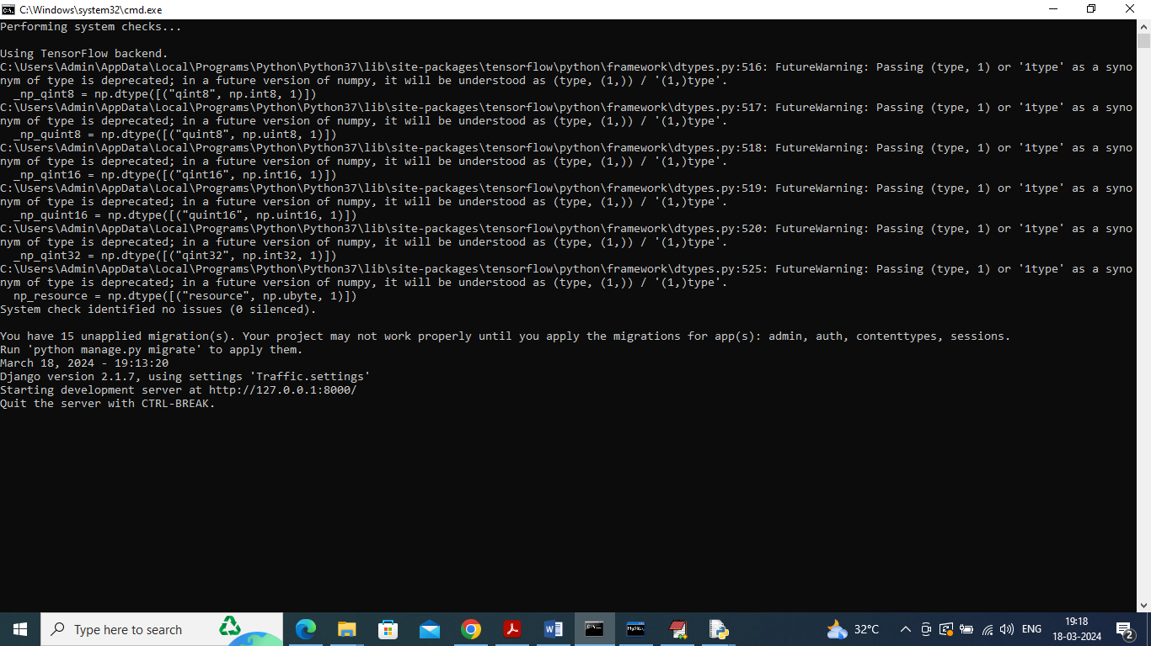

In above screen python server started and now open browser and enter URL as <http://127.0.0.1:8000/index.html> and press enter key to get below page

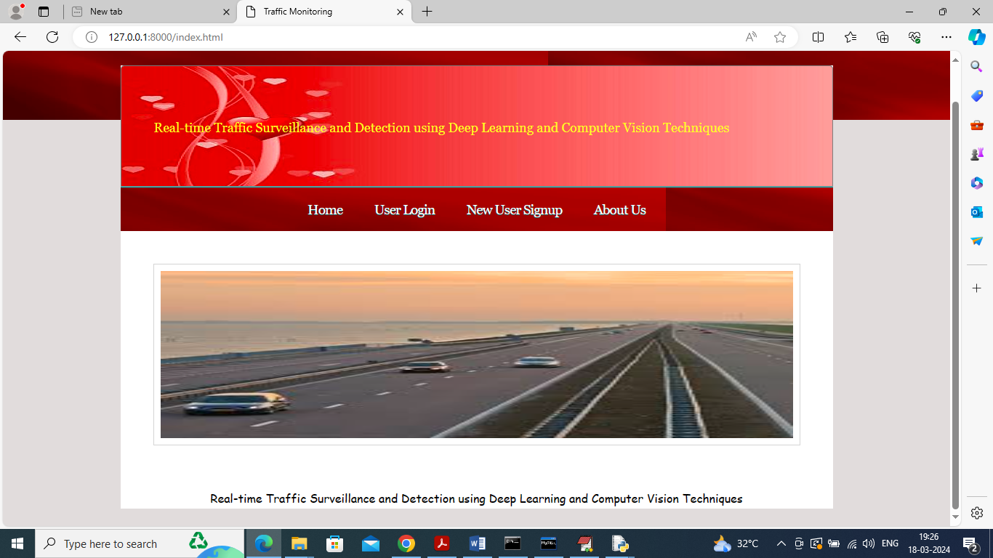

In above screen click on ‘New User Sign up’ link to get below page

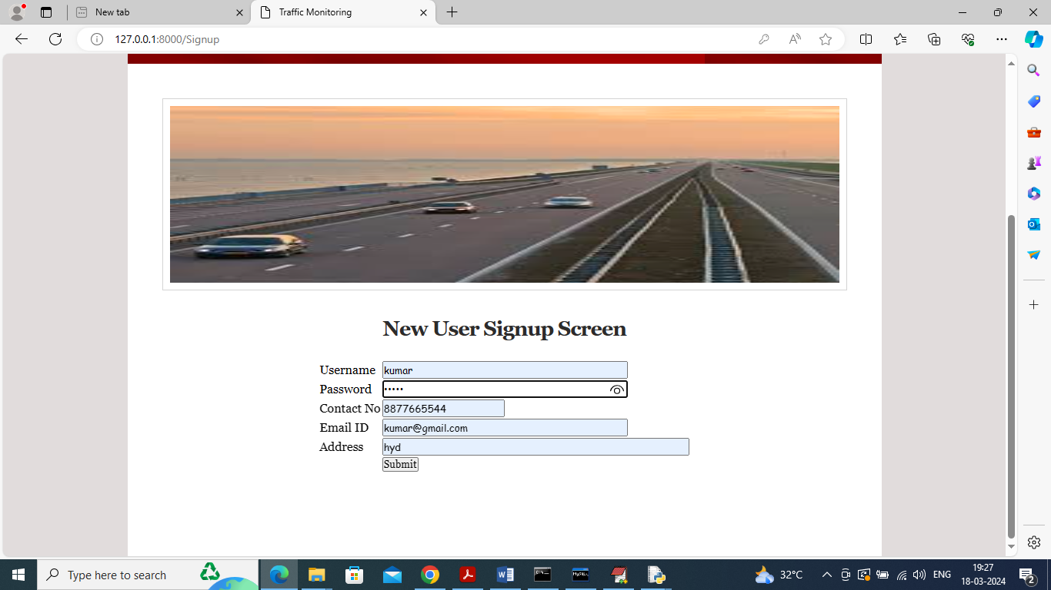

In above screen user is entering sign up details and then press button to get below page

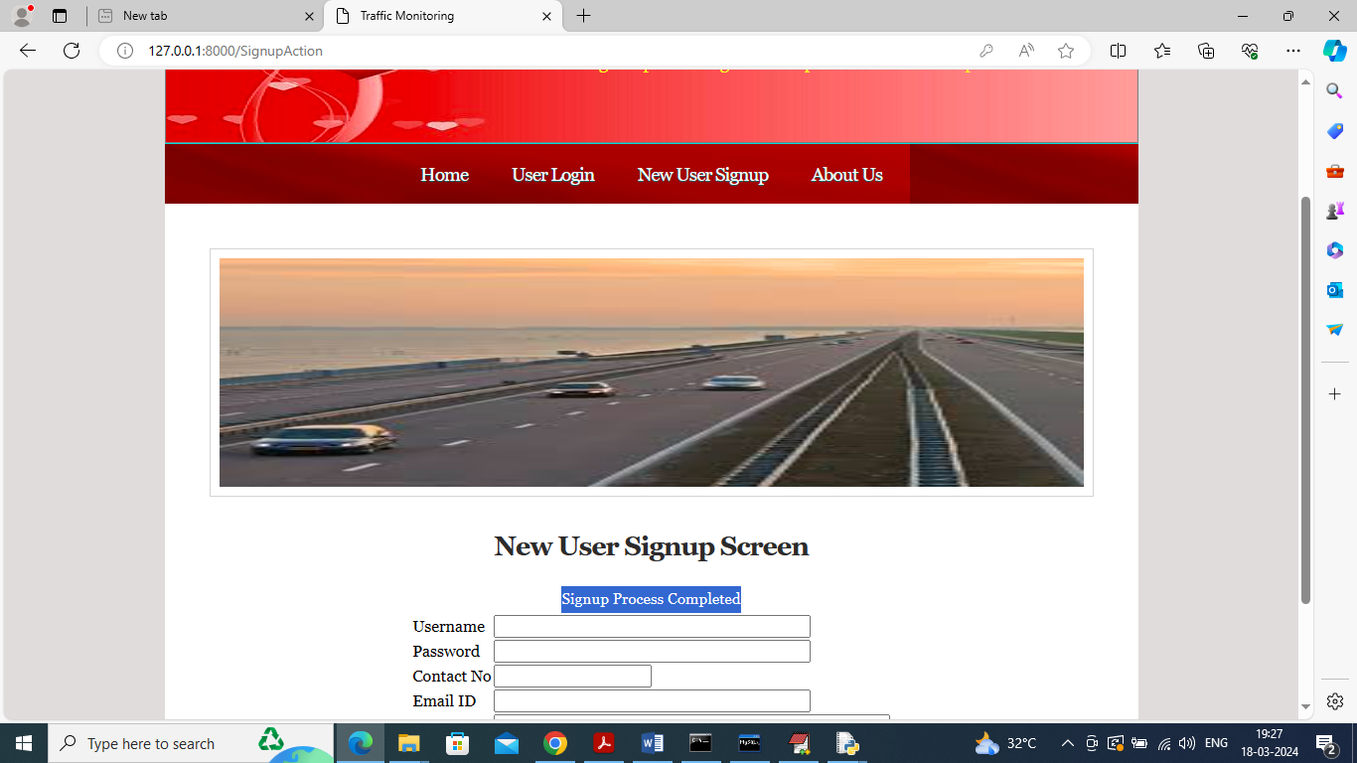

In above screen sign up process completed and now click on ‘User Login’ link to get below page

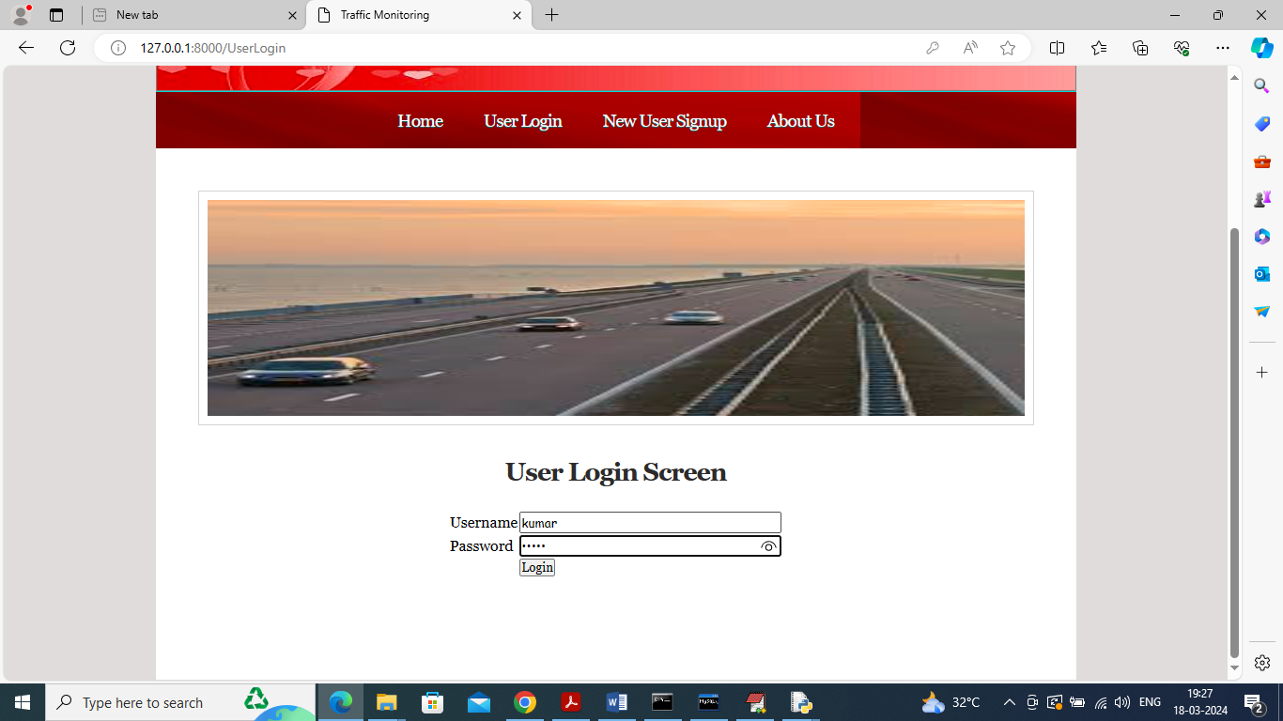

In above screen user is login and after login will get below page



In above screen click on ‘Train YoloV7 Algorithm’ link to train YoloV7 and then perform prediction on test data to calculate accuracy and other metrics and then will get below page

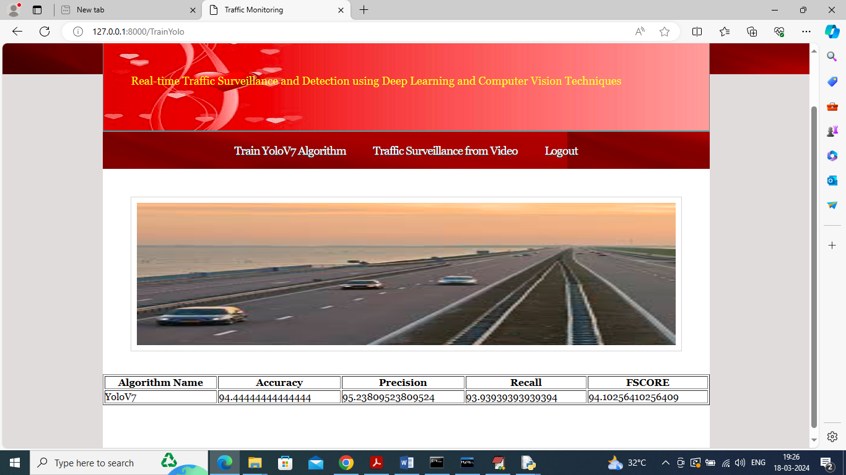

In above screen YOLO got 95% accuracy and can see other metrics like precision, recall and FSCORE and now click on ‘Traffic Surveillance from Video’ link to get below page

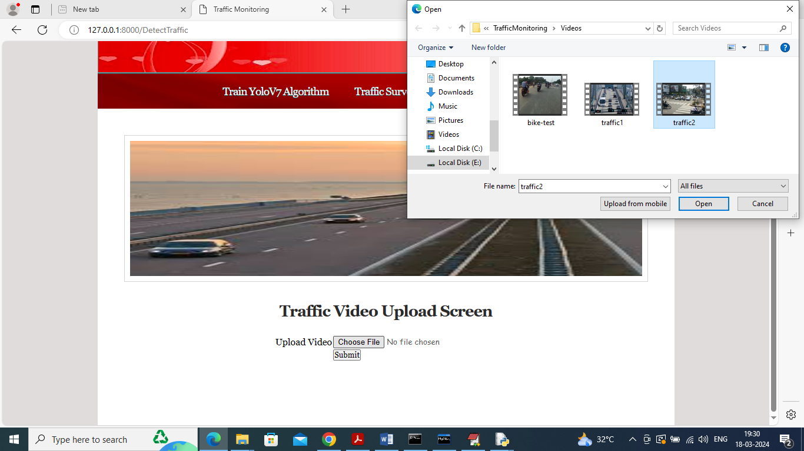

In above screen selecting and uploading video and then click on ‘Open’ and ‘Submit’ button to get below output

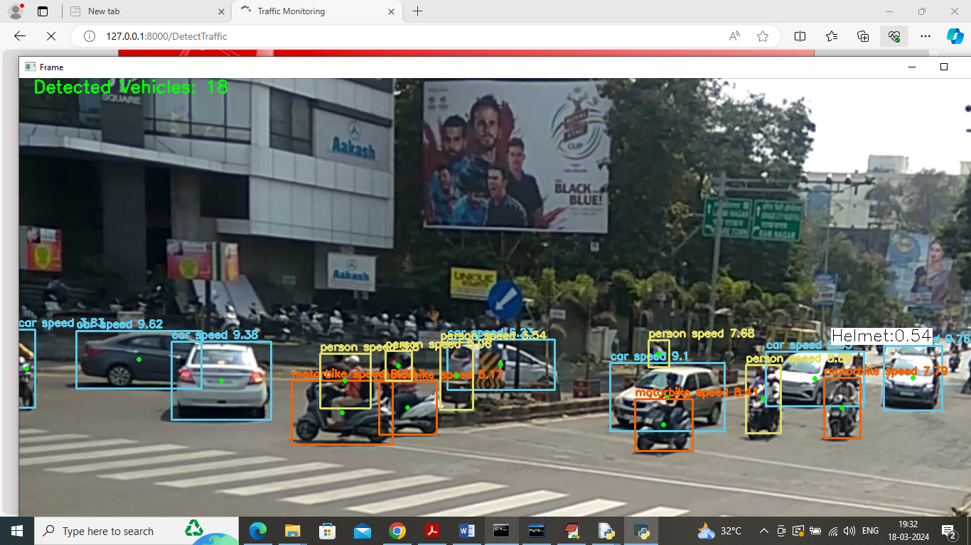

In above screen can see classify vehicles as Car, motor bike and can see Helmet class also in white colour text and in top in green colour text can number of detected traffic vehicles

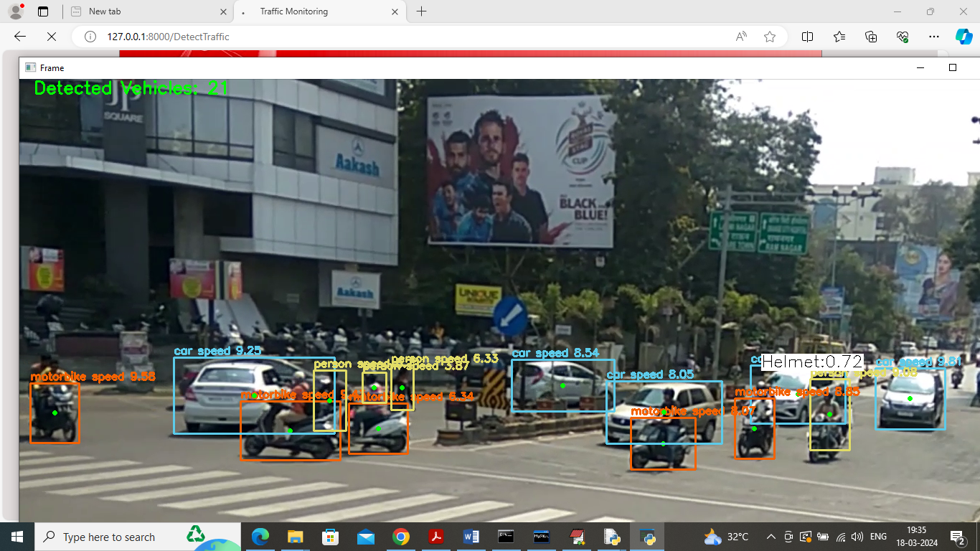

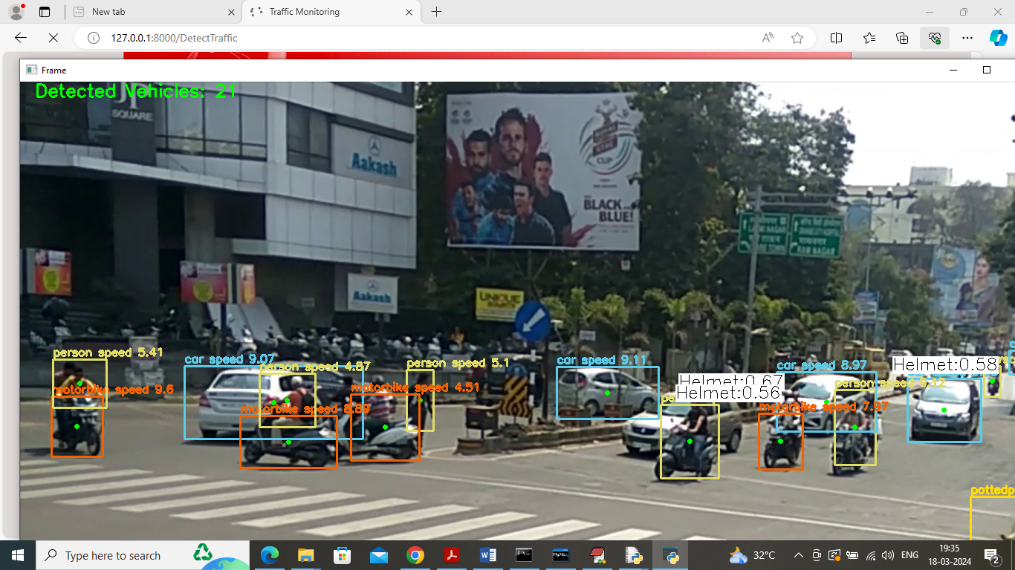

So in above screen as per your requirements detecting helmet, vehicles, speed, type of vehicles etc. similarly you can upload and test other videos

In below screen can see output from other video

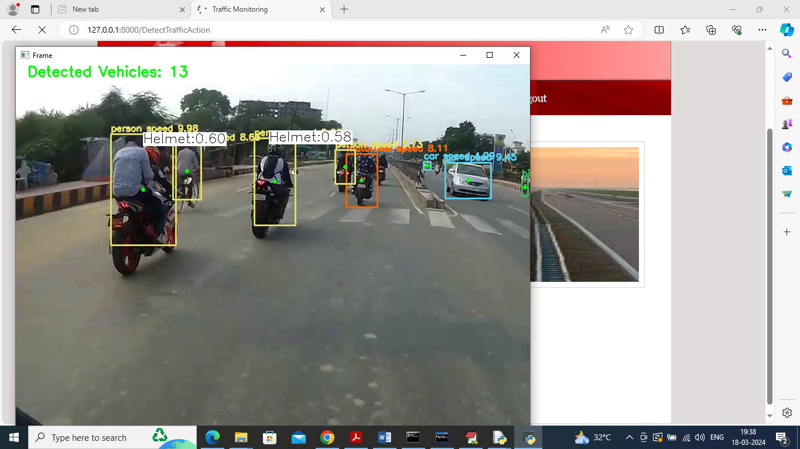

Similarly upload and test other videos